Shaped Week 3

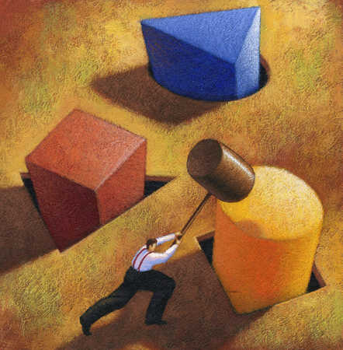
My Skills make me Belong: Abilities for my Vocation

Exodus 35:30 – 36:3
Then Moses said to the Israelites: See, the Lord has called by name Bezalel son of Uri son of Hur, of the tribe of Judah; he has filled him with divine spirit, with skill, intelligence, and knowledge in every kind of craft, to devise artistic designs, to work in gold, silver, and bronze, in cutting stones for setting, and in carving wood, in every kind of craft. And he has inspired him to teach, both him and Oholiab son of Ahisamach, of the tribe of Dan. He has filled them with skill to do every kind of work done by an artisan or by a designer or by an embroiderer in blue, purple, and crimson yarns, and in fine linen, or by a weaver—by any sort of artisan or skilled designer.
Bezalel and Oholiab and everyone skilful to whom the Lord has given skill and understanding to know how to do any work in the construction of the sanctuary shall work in accordance with all that the Lord has commanded.

Moses then called Bezalel and Oholiab and everyone skilful to whom the Lord had given skill, everyone whose heart was stirred to come to do the work; and they received from Moses all the freewill-offerings that the Israelites had brought for doing the work on the sanctuary. They kept bringing him freewill-offerings every morning.

Psalm 18: 30 – 37 God leads and teaches me
This God—his way is perfect;
the promise of the Lord proves true;
he is a shield for all who take refuge in him.
³¹ For who is God except the Lord?
And who is a rock besides our God?—
³² the God who girded me with strength,
and made my way safe.
³³ He made my feet like the feet of a deer,
and set me secure on the heights.
³⁴ He trains my hands for war,
so that my arms can bend a bow of bronze.
³⁵ You have given me the shield of your salvation,
and your right hand has supported me;
your help* has made me great.
³⁶ You gave me a wide place for my steps under me,
and my feet did not slip.
³⁷ I pursued my enemies and overtook them;
and did not turn back until they were consumed.

1 Corinthians 3: 5 – 15
5 What then is Apollos? What is Paul? Servants through whom you came to believe, as the Lord assigned to each.⁶I planted, Apollos watered, but God gave the growth.⁷So neither the one who plants nor the one who waters is anything, but only God who gives the growth.⁸The one who plants and the one who waters have a common purpose, and each will receive wages according to the labour of each.⁹For we are God’s servants, working together; you are God’s field, God’s building.

10 According to the grace of God given to me, like a skilled master builder I laid a foundation, and someone else is building on it. Each builder must choose with care how to build on it.¹¹For no one can lay any foundation other than the one that has been laid; that foundation is Jesus Christ.¹²Now if anyone builds on the foundation with gold, silver, precious stones, wood, hay, straw—¹³the work of each builder will become visible, for the Day will disclose it, because it will be revealed with fire, and the fire will test what sort of work each has done.¹⁴If what has been built on the foundation survives, the builder will receive a reward.¹⁵If the work is burned, the builder will suffer loss; the builder will be saved, but only as through fire.

Matthew 11: 28 – 30
28 ‘Come to me, all you that are weary and are carrying heavy burdens, and I will give you rest.²⁹Take my yoke upon you, and learn from me; for I am gentle and humble in heart, and you will find rest for your souls.³⁰For my yoke is easy, and my burden is light.’

Introduction

God shapes us to fit into the “jigsaw puzzle” of the Church by giving us spiritual gifts and planting passion in our hearts. The natural abilities we received at birth are linked to our spiritual gifts and tied to our passion. This makes each Christian a unique blessing to the Church and through the church to the world. If we develop our natural abilities, we are like Bezalel and Oholiab, who used their artistic skill to build a sanctuary for the Lord (Exodus 35:30 – 36:3).

I have a friend who describes his participation in the church in the following way: “I am not spiritual. I am however a skilled builder and I can help the church in practical ways.” Despite my best efforts I have not been able to shift his mindset. The truth is some of us pray with our hands. The Old Testament reading is the best example of this – the spiritual work that Bezalel and Oholiab were called to was to build. The property committee is as spiritual as the prayer meetings we have at church.

In the lesson from the Old Testament we heard how after Moses received the Ten Commandments, God ordered him to construct a Permanent Tabernacle for the people to worship in. Moses as leader had to summon the people together and ask for their help. Moses asked the people to donate the materials that were required. Exodus 35 tells us that “Moses said to all the congregation of the Israelites: This is the thing that the Lord has commanded: Take from among you an offering to the Lord; let whoever is of a generous heart bring the Lord’s offering: gold, silver, and bronze; blue, purple, and crimson yarns, and fine linen; fine leather; acacia wood, oil for the light, spices for the anointing-oil and for the fragrant incense, and onyx stones and gems …” (Exodus 35). Exodus tells us that people responded generously and that they had more than was needed to build the Tabernacle. The problem was that it is no good having a pile of materials without anyone to assemble them and construct the Tabernacle. In the Exodus story Moses once again called upon the people and said, “ All who are skilful among you shall come and make all that the Lord has commanded: the tabernacle, its tent and its covering, its clasps and its frames, its bars, its pillars, and its bases; the ark with its poles, the mercy-seat, and the curtain for the screen; the table with its poles and all its utensils, and the bread of the Presence; the lampstand also for the light, and the oil for the light; and the altar of incense …. ”. The people came forward and used their skills to build the Tabernacle. But the problem was that they needed an architect and a designer to tell them how to build the Tabernacle, and so once again Moses went out and found two people to lead the builders – Bezalel and Oholiab. But what Moses says this time is important. Moses says, “See, the Lord has called by name Bezalel … and he has filled him with divine spirit, with skill, intelligence, and knowledge in every kind of craft, to devise artistic designs, … and he has inspired him to teach, both him and Oholiab … He has filled them with skill to do every kind of work done by an artisan or by a designer or by an embroiderer…

Our Abilities build the Church

The vocation of those Israelites was to build a physical church. Several thousand years later, God called God’s people in Corinth to build a church, but this time, not of brick and mortar but of people. God had a new kind of church in mind – God’s new church was based on relationships, on people, on community. Paul found it very helpful to use words from the building industry when he described God’s work in creating this Church community in Corinth. Paul said we always start a Christian community on the foundation of Christ (1 Corinthians 3:11). And then he said, “There is not one builder, but many. Each person uses different skills and different materials to extend the Kingdom of God.”
What he was saying was that every believer is uniquely shaped to build up this community of people; and very believer has different skills that they can use to develop this community of people

Our Abilities wherever we are

The message for us today is that our natural abilities that are given to us by God; these abilities also give us clues as to what our vocation is. Wherever we spend our lives – whether it is in the home, or at school, at work, or even at leisure – we develop skills, and we can use these skills to build upon the foundation of Christ.

There are many different vocations, and very few of these are exercised inside the Church building! We serve Christ with our skills and we use these same abilities to serve the world that God loves always in the name of Christ. In doing this we can bring the needy world under the lordship of Christ. It has been said that where the needs of the world and your talents cross, there lies your vocation.

Our Abilities Yoked to Christ

One of the problems that I have discovered in encouraging people to use their God given skills to build up the Church, is that many of us find life stressful and exhausting. We use or may have used our skills Monday to Friday in secular employment and so when we think of using those same skills in the building up of God’s Kingdom, we are too tired to do so.

What we need to realise as Christians, is that Jesus understands this and invites us, “Come to me, all you that are weary and are carrying heavy burdens, and I will give you rest” (Matthew 11:28). In living out our vocations, we should not be depending upon our own strength to build a Christian community. Instead Jesus counsels us, “Take my yoke upon you and learn from me! For my yoke is easy and my burden is light” (Matthew 11:29 – 30). And so, in partnership with Jesus, we have the strength to keep using our skills to build the Kingdom of God. Perhaps another problem is that we haven’t matched our skills with our passions, because if we are passionate about something, we receive renewed energy.

Conclusion

To bring the three week’s sermons together: In order to discern our vocation, the first thing we need to do is discover our spiritual gifts. Then secondly, we need to say what we are passionate about. Then thirdly, we must identify our natural abilities and skills. What we need to realise is that in order to build up the Body of Christ, all of us must use our God given gifts, passion and abilities.

Let me conclude by telling a brief story of a man who was taking a walk down a country road, when he came across a stone quarry in which several men were working. He questioned several of them about what they were doing. The first replied irritably, “Can’t you see? I’m hewing a stone.” The second answered without looking up,” I’m earning $500 a week.” When the same question was put to the third man, he stopped, put his pick down, stood up, stuck out his chest and said, “If you want to know what I’m doing, I’m building a cathedral.”

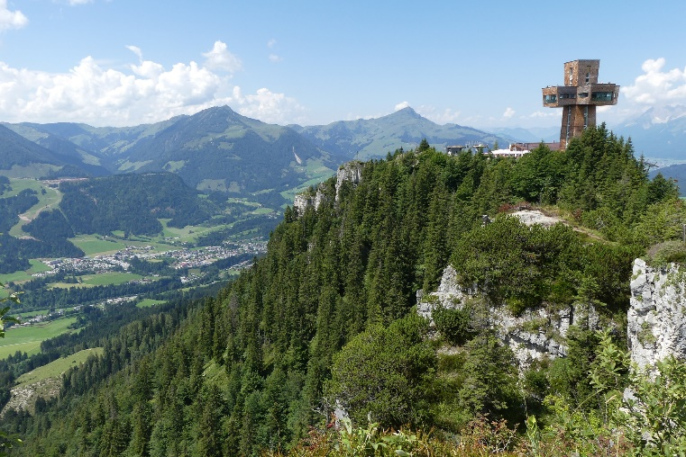
It is a matter of how we understand what we are used for: The first man could not see beyond his pick, and the second beyond his Friday pay packet. But the third man looked beyond his tools and his wages to the ultimate end he was serving. He was using his abilities to co-operate with the architect to produce something great.

What abilities has God given you? Are you using them in co-operation with Chief Architect? No matter how small a contribution your abilities can make, God wants to use you to build his Kingdom.

My Skills make me Belong: Abilities for my Vocation

Skills to Serve God

Read Exodus 35:30 – 36:3

Moses used three words to describe God’s action in the lives of Bezalel and Oholiab. How did God’s action enable them to grow in their skills?

called _____________________________________________________________
filled______________________________________________________________
inspired____________________________________________________________

With these words in mind, write down how God has worked in your own life.

called _____________________________________________________________
filled______________________________________________________________
inspired____________________________________________________________

Skills to Plant and Build

Read 1 Corinthians 3:5 – 15

What important point is Paul making about our skills in verses 5 – 9?
____________________________________________________________________________________________________________________________________________
______________________________________________________________________.

- Why does Paul lay special emphasis on the foundation of our work?
______________________________________________________________________
______________________________________________________________________
____________________________________________________________________________ .

- Does every “vocation” from God have to be exercised “in the Church”? Why or why not?
________________________________________________________________________
________________________________________________________________________
________________________________________________________________________.

- What kind of materials are you using in the building of your life’s work, your vocation?
_____________________________________________________________________________ _____________________________________________________________________________
_____________________________________________________________________________.

Skills Yoked to Christ

Read Matthew 11: 28 – 30

- What do these verses tell us about how Jesus understands us?
_________________________________________________________________________________________________________________________________________________
______________________________________________________________________.

- What warning is there in these verses?
__________________________________________________________________________________________________________________________________________________________________________________________________________________________.

