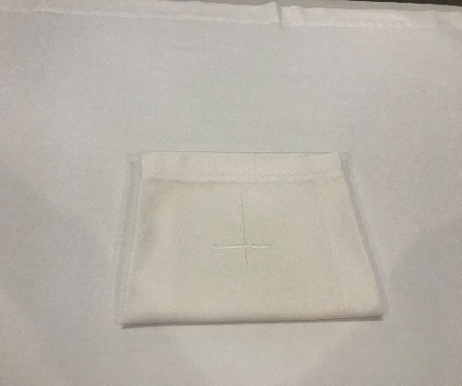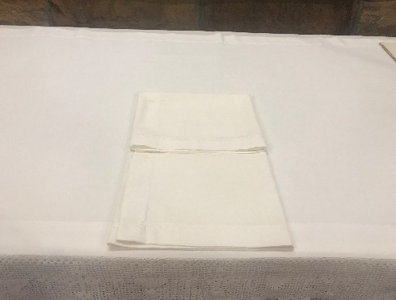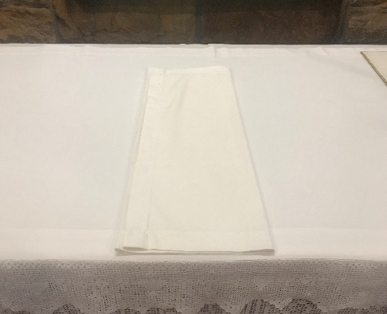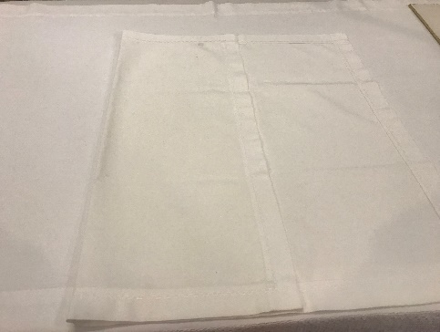

**Note: the corporals are stored in the drawers in the vestry, the small room on the right of the altar. The wardens have keys if the vestry is not open.**

**Step 1:**

The cross on the corporal is

closest to you

**Step 4:**

Fold the top third down

**Step 5**

Fold the bottom third up

## How to fold a corporal

**Step 3:**

Fold the right third over the left third

**Step 2:**

Fold the left third towards the right

Corporal