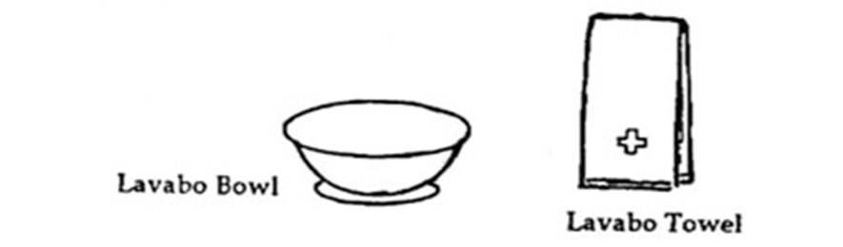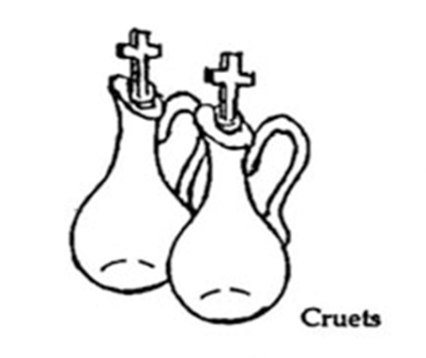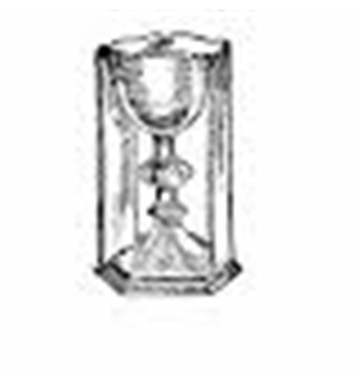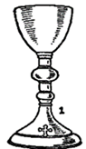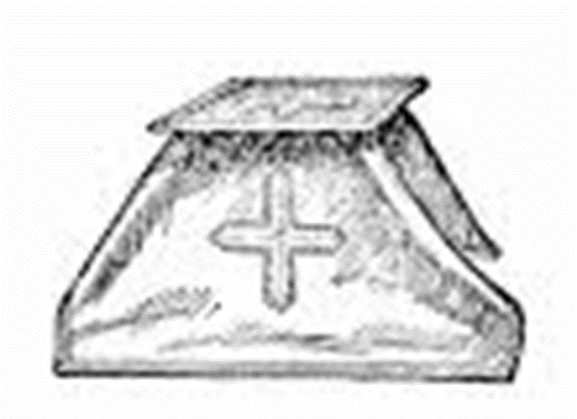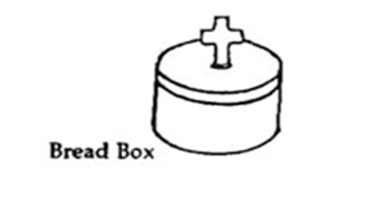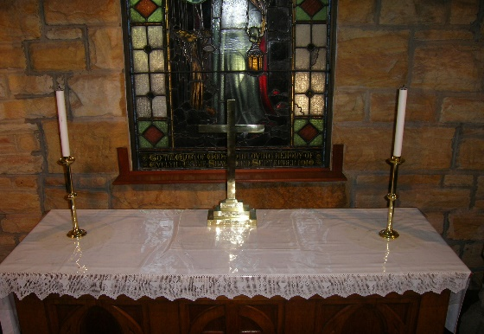

## How to set the Altar for Holy Communion

1. Chalice with burse and veil (see page 4)

2. Chalice with purificator.

3. Small chalices

1

5. Water (LHS) and Wine (RHS) cruets. Handles face AWAY from you.

4. Bread Box with three gluten free wafers alongside

**Step 3:** The Creedence table is set up as below. The vessels below are in the safe in the vestry, the small room to the right of the Altar

**Step 2:** Ready the Creedence Table. The Creedence table is the small table to the right of the altar.

6

2

3

6. Lavabo Towel: white cloth located in drawers .

**Step 4:** If you are the Eucharist assistant, pass the vessels in the order depicted, moving in a clockwise direction.

5

4

Place candles and cross on windowsill and fold/remove dust cover.

Place cover under the Lord’s Table.

Place candles back on candle mats

on table.

**Step 1:** Ready the Altar. The Altar is the centrepiece table in the church.