Ministers and Ministries
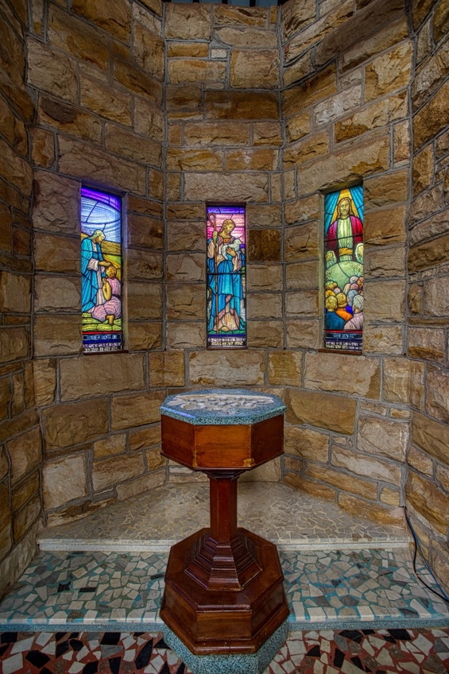

Here are the ministers appointed to church ministries. The ministers in the church are the baptized. Each minister is called to shine as a light for Christ in the world. Each minister partners with God in mending creation.

Licensed Ministers 2022
RECTOR | The Rev’d Dr Desiree Snyman
ASSOCIATE CLERGY | The Rev’d Geoff Vidal
 | The Rev’d John Kidson
 | The Rev’d Doug Bannerman
 | The Rev’d Greg Ezzy
LICENSED LAY MINISTERS | Charlie Handley
 | Mark Stuckey
 | Barbara Fewtrell
 | Susan Fitzpatrick

Parish Council 2022
WARDENS | Jenny Noble
 | Bruce Sharp
COUNCILORS | Charlie Handley
 | Margaret Brown
 | Robyn Hannah
 | Des Fitzpatrick
 | Amanda Middleton
 | Graham Ireland
 | Kaye Fry
 | Mark Stuckey

Other roles 2022
SYNOD REPS. | Mark Stuckey
 | Cathi Angus.
ALTERNATE SYNOD REP. | Susan Fitzpatrick.
TREASURER | Anne Bryce
AUDITOR | Chris de Wall
PARISH COUNCIL CHAIR | Amanda Middleton
PARISH COUNCIL SECRETARY | Des Fitzpatrick
SAFE MINISTRY OFFICER | John Noble
OP SHOP MANAGER | Phil Cowie
PASTORAL CARE COORDINATOR | Lynne Watt
SOCIAL COORDINATOR | Amanda Middleton
SUNDAYS @ 9 LAY MINISTRY COORDINATOR | Helen Nicholson
ANAM CARA COORDINATOR | Charlie Handley
ONLINE COMMUNITY ENGAGEMENT | Robyn Hannah
FRIDAYS @ 10 COORDINATOR | Geoff Vidal
MESSY CHURCH COORDINATOR | Barry Campey
COVE COORDINATOR | Alan Larsen

Administration Staff
Purpose: To serve the Parish

Role / Responsibility | Staff
Support the administration and finance of Alstonville Anglicans.  Respond to parishioner enquiries.  Portfolios: Finance, Property, Community Engagement, Pastoral Care | Jo B
Provide administrative support to the Rector.  Portfolios: Worship, Spirituality, Online Community Engagement, Leadership | Anne W

Ministers and Ministries for Pastoral care

Purpose: To show Christ’s love in action

Ministry | Description | Ministers
Pastoral Care portfolio | Coordinates Pastoral Care | Lynne Watt
Hospitality | Offers catering for funerals and catering policy events. | In Abeyance
Aged care | The reserved sacrament for aged care residents. | Barbara F
Crisis care | Responds to people in dire straits. | Lynne W
Hospital visiting | Visiting those in hospital. | Barry C
Home Communion | Licensed ministers take the reserved sacrament to people. | Lynne W
Prayer chain | Praying for those in need. | Lynne W
Socials | Events bringing all of the diverse congregations together.
Home Visiting | Visiting people who are “house-bound.” | Barry C
Helping hands | A team which supports those in need of practical help such as gardening, cleaning, and shifting furniture. | Barry C
Fellowship group | Friends sharing a lunch together at Bung Raya. | Carol V
Breakfast club | Meets on the 2nd Tuesday of each month. | Margaret B  Clair B
Breakfast club | Meets on the 2nd Tuesday of each month. | Geoff V

Ministers and Ministries for Worship and Spirituality

Purpose: To glorify God. Proclaim the Good News. Teach, baptise and nurture new believers.

Ministry | Description | Minister
Anam Cara Contemplative Church | In discovering the wisdom tradition at the heart of contemplative Anglican Christianity, this meditative worship community nurtures silence through beautiful music, sacred chant, and ritual. Vigils, quiet days, community feasts, retreats and teachings to deepen contemplative practice. | Charlie H
Fridays @ 10 am | A middle of the road traditional Anglican Worship Service using the Prayer Book, two hymns are sung, and morning tea follows. | Geoff Vidal
Sundays @ 9 am | A re-traditioning Anglican Worship service based on the Prayer Book, but with contemporary and refreshing liturgical language. | Helen N
Messy Church | Creativity and worship on the 4th Sunday of each month from 4 pm to 6 pm.  Building community with faith seekers and families. | Barry C
Messy Life? Church | Faith development, content rich teaching and discussion in the context of contemporary worship in safe community. | Desiree S
Online ministry | Engaging, innovative worship in an online community. | Robyn H
LiFE groups | To Live in Faith Every day. LiFE groups are centered on Bible study, relationships, and prayer. | Greg E
Sacristans | The sacristy is a room where the sacred vestments, vessels and all else that is necessary to perform the liturgy are kept. | Lyn S
Music Coordinator | Worshipping God through music | Ros S
Floral group | Worshipping God though floral art | Nancy W
Baptism Preparation | Baptism into Christ and the Community of Christ | Desiree S
Marriage preparation | Prepare and Enrich is a an international relationships building program | Paul & Lesley E
Cursillo | A weekend away exploring the Christian faith. | Mark S

Ministers and Ministries for Online Community Engagement

Purpose:
To respond to human need by loving service.
To offer online worship.
To embody a 21st Century Church.
To be a compassionate but provocative voice of inclusive Christianity.

Ministry | Minister
Livestream and YouTube | Robyn H
Bulletin | Ann W
Newspapers and radio | Ann W
Marketing (flyers, posters etc.) | Ann W
Social media | Ann W

Ministers and Ministries for Community Engagement
Purpose: To respond to human need by loving service.

Ministry | Description | Minister
CoVe | Community-on-the-Verge | Alan L
Play Place | A place for children to meet other children and parents to relax with other parents. | Margaret B
Sew helpful | Friendship through craft.
Mission support | Showing God’s love in action through supporting projects that create heaven on earth. | Parish Council
LinC | A network providing help in times of need due to incapacitation. | Diana W
Fete | A fundraising community event. | Parish Council

Ministers and Ministries for the Op Shop
Op Shop Portfolio | Offering quality furniture, household good and clothing at reasonable prices. | Phil C

Ministers and Ministries for Good Governance

Purpose: To have outstanding facilities and sustainable resources for mission & ministry

Ministry | Description |  | Minister
Finance | Overseeing procedures to ensure fiscal and sustainable responsibility |  | Anne B
Parish Administration | Parish Roll  Checklists  Rule of life (routines)  Church Diary | Facility Hire  Office assistants  Office and church supplies  Incident report management  Fire risk compliance  Risk Management compliance | Jo B
Safe Ministry | Safe Ministry Training Faithfulness in Service |  | John N

Ministers and Ministries for Property
Property | Mowing roster (Barry C)  Sanctuary cleaning roster  Maintenance (Lesley E, Bruce S, Colin A, Graham I) | Phil C

Alstonville Anglicans Info
Web: anglicans.live
Phone: 02 6628 0231
Office Email: office@anglicans.live
Priest’s Email: priest@anglicans.live
Ministry Admin ma@anglicans.live
Address: 6-8 The Avenue Alstonville 2477 NSW
Post: PO Box 451 Alstonville NSW 2477
ABN 16835287578
Bank: BSB 705 077 #00032931
Anglican Diocese of Grafton Info
Web: graftondiocese.org.au
Phone: 02 6642 4122
Email: admin@graftondiocese.org.au
Address: Level 1, 50 Victoria Street
Post: PO Box 4 Grafton NSW 2460
Bishop Murray Harvey bishop@graftondiocese.org.au

Director of Professional Standards
1800 370 757
dps@graftondiocese.org.au

Diocese of Grafton Registry Staff
Chris Nelson
Registrar/General Manager
registrar@graftondiocese.org.au

Maree Collett
Personal Assistant to the Bishop and MDO
pa@graftondiocese.org.au

Kaytrina Jessup
Personal Assistant to the Registrar
admin@graftondiocese.org.au

Jenny Brock
Insurance & Accounts Officer
insurance@graftondiocese.org.au
debtors@graftondiocese.org.au

Linda Butler
Administration Assistant
linda.butler@graftondiocese.org.au

